## **Langchain App Technical Document**

### **Introduction**

The Langchain application harnesses advanced language models to empower users in generating mermaid diagrams from text-based instructions. This comprehensive technical document provides an intricate exploration of the app's architecture, design rationale, token optimization techniques, adaptability with various language models, cost-effectiveness analysis, and strategies for ensuring reliability and correctness.

### **Design and Architecture**

The Langchain app embraces a modular design with three key components: instruction breakdown, mermaid markup generation, and error handling. These components collaborate harmoniously within the framework of a SequentialChain, facilitating step-by-step execution of the diagram generation process.

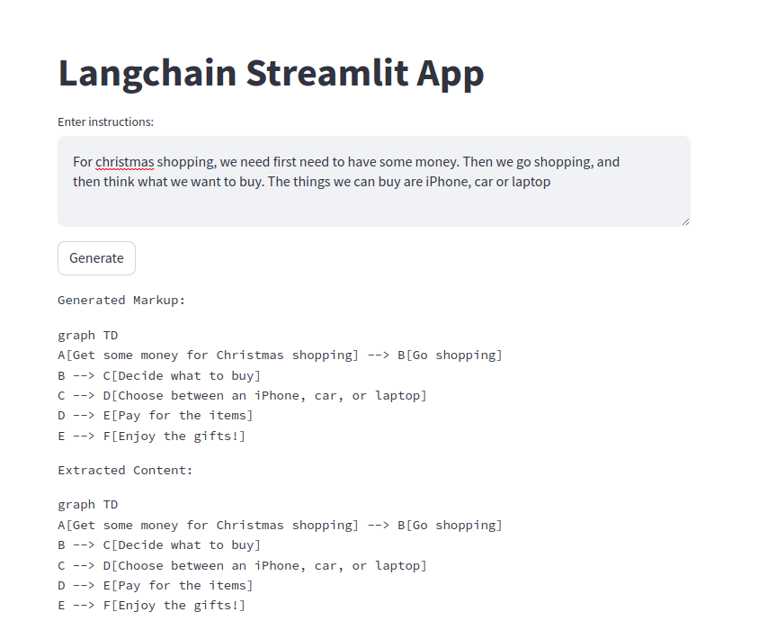

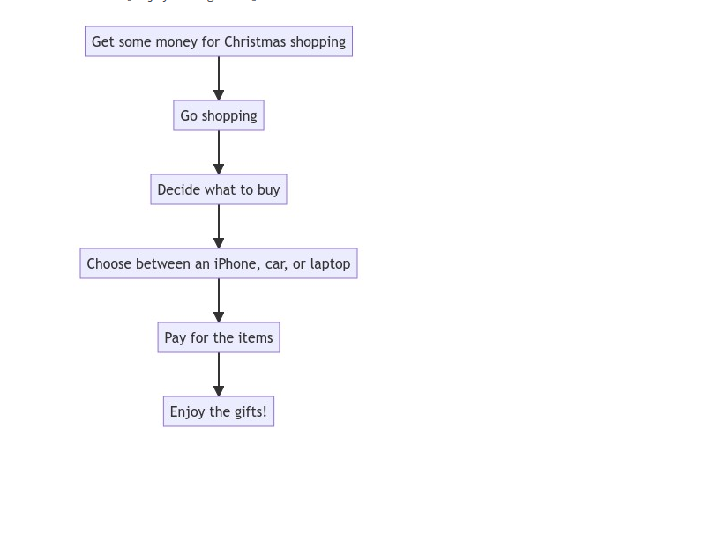

### **Technical Details**

#### Language Models and Token Consumption

Central to the Langchain app is the utilization of the LLMS (Language and Logic Modeling Service) model from OpenAI. This model operates based on tokens, encompassing prompt tokens used for initiation and completion tokens generated as outputs. An illustrative example of token usage is as follows:

* Tokens Used: 652
* Prompt Tokens: 321
* Completion Tokens: 331

### **Prompts Explored**

The development of the Langchain app involved meticulous exploration of diverse prompts, spanning instruction breakdown, mermaid markup generation, and error correction. These prompts play a pivotal role in guiding the language model to produce accurate and contextually appropriate outputs.

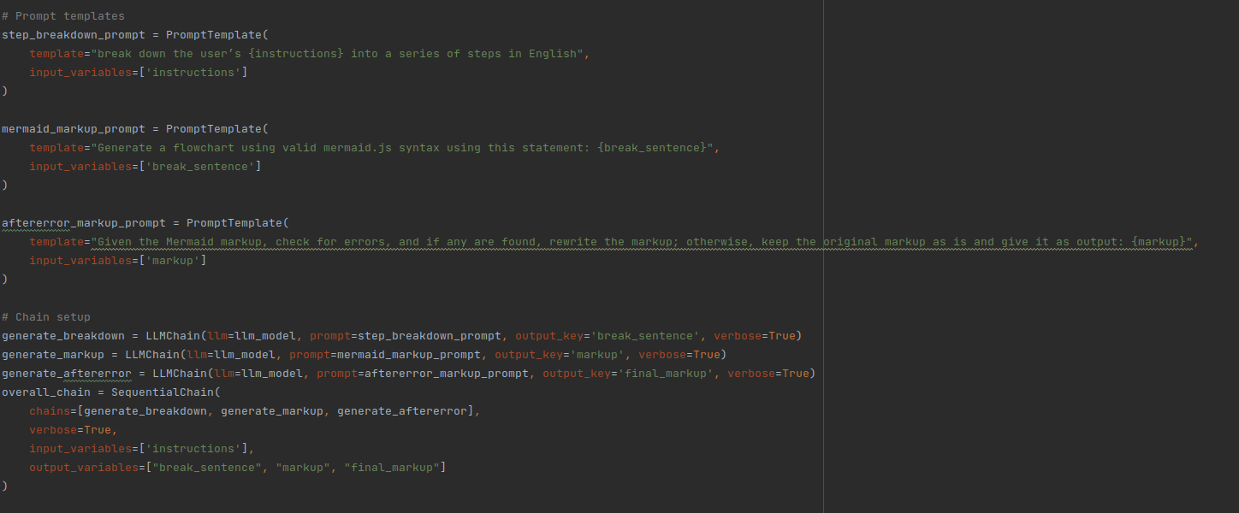

### **Cost Considerations**

The economic implications of the Langchain app are intrinsically tied to token consumption originating from interactions with the OpenAI model. For a recent execution, the cumulative cost was estimated at $0.01304. This nominal cost exemplifies the app's cost-effectiveness and accessibility for users.

### **Token Optimization Strategies**

#### Minimizing Token Utilization

The Langchain app employs a range of token optimization strategies to curtail costs effectively:

* **Concise Prompts**: Employing concise yet precise prompts to convey instructions efficiently.
* **Output Truncation**: Implementing output truncation to control token expenditure while preserving clarity.

### **Extensibility with Different Language Models**

The Langchain app is ingeniously designed to accommodate diverse language models tailored to varying task complexities.

#### Adaptive Model Selection

* **Task Complexity Evaluation**: The app dynamically evaluates the complexity of user instructions.
* **Model Tailoring**: For uncomplicated tasks, an efficient yet less resource-intensive language model is deployed.
* **Complex Task Handling**: Intricate tasks activate a more sophisticated model, optimized for intricate processing.

### **Reliability and Program Correctness**

To bolster reliability and ensure program correctness, the Langchain app intricately integrates OpenAI's API with robust error-handling mechanisms. The SequentialChain's stepwise execution minimizes error cascades. Rigorous testing on diverse inputs attests to the consistency and precision of mermaid diagram generation.

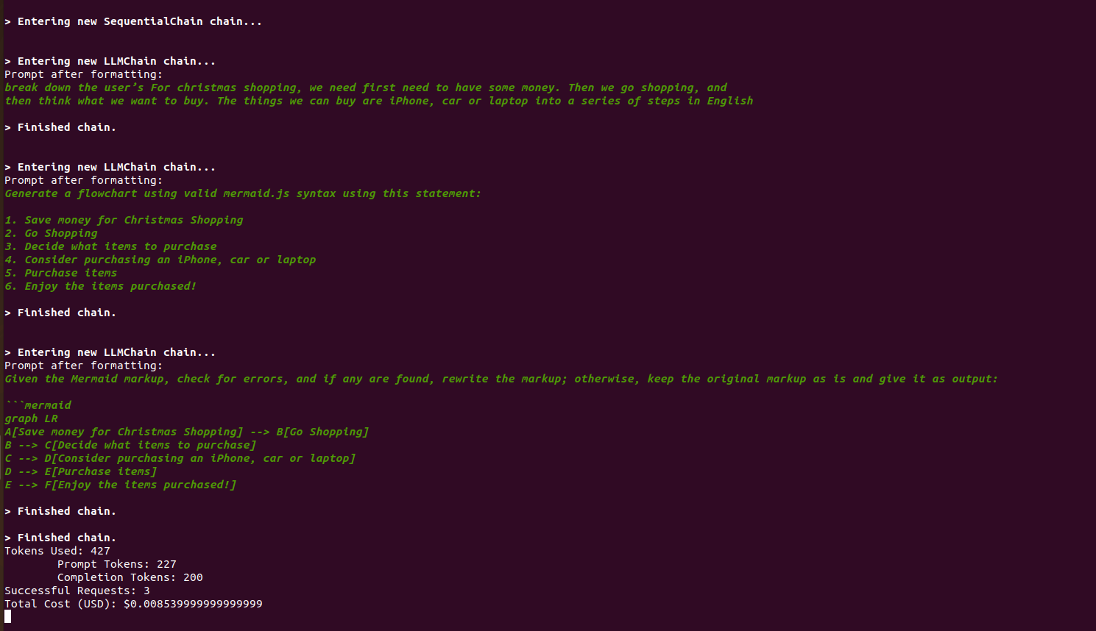

### **Conclusion**

The Langchain app stands as a remarkable testament to the harmonious fusion of cutting-edge language models and automated diagram generation. Its modular architecture, adept token optimization, seamless adaptability to diverse language models, prudent cost management, and unwavering reliability collectively underscore its significance as an invaluable tool for users seeking seamless diagram creation.